Phase 3

Project Design Phase

Phase 3: Project Design Phase

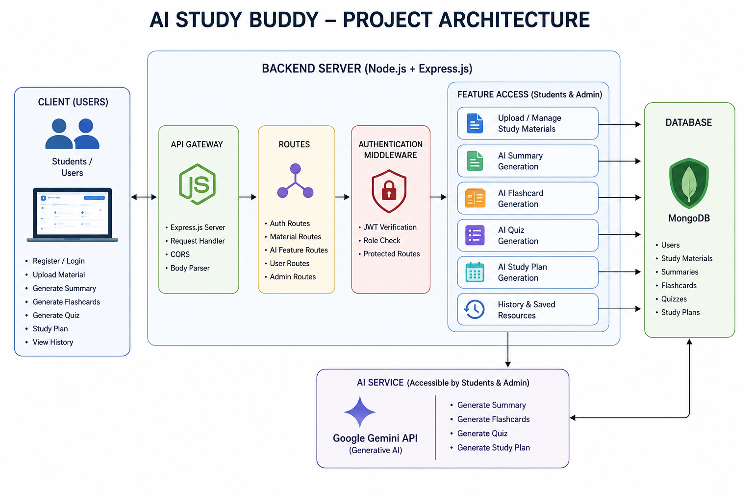

The AI StudyBuddy backend follows a modular RESTful architecture designed to provide secure, scalable, and AI-powered learning services. The system processes client requests through Express.js, validates users using JWT authentication, interacts with the MongoDB database for data storage, and communicates with the Google Gemini AI API to generate intelligent study resources.
The architecture separates authentication, business logic, AI services, and database operations into independent modules, making the application easier to maintain, extend, and debug.
Components Definition
• Client Application: The frontend (React.js) allows users to register, log in, upload study material, and access AI-powered features such as summaries, quizzes, flashcards, and study plans through REST APIs.

• Express Server: The Express.js server receives HTTP requests, handles routing, processes middleware, and sends appropriate responses to the client.

• Authentication Middleware: JWT-based middleware verifies user identity, protects private routes, and ensures that only authenticated users can access AI services and study resources.

• Route Handlers: Routes manage API endpoints related to user authentication, study materials, AI features, and administrative operations.
• AI Service Layer: A dedicated AI service communicates with the Google Gemini API to generate summaries, quizzes, flashcards, and personalized study plans based on the user's study content.

• Database Layer: MongoDB, together with Mongoose ODM, stores user information, uploaded study materials, and AI-generated learning resources securely.

